Updated: 7/18/19

**Materials**:

* Gloves
* Culture samples
* 90% Acetone (fridge)
* Deionized water
* Micro-pipette (1 mL max)
* Micro-pipette (20-200µg)
* Refrigerated Centrifuge
* Bead-mill
* Refrigerator
* Photo Spectrometer
* Fume Hood

1. Minimize lights in laboratory as much as possible to decrease light damage to pigments.
2. Set the refrigerated centrifuge to 4℃.
3. Allow samples to thaw in the dark. Keep on ice after thawing.
4. Ce54ntrifuge for 20 min at max RPM (14.8) and 4℃ .
5. Remove samples from centrifuge and very carefully put them on ice.
6. Using the 1mL maximum micro-pipette, carefully remove supernatant without disturbing pellet. Remove any remaining supernatant with the 20-200µg micropipette.
7. Add small amount of beads to tubes.
8. Add 1mL of 90% acetone to each tube once the supernatant has been drained.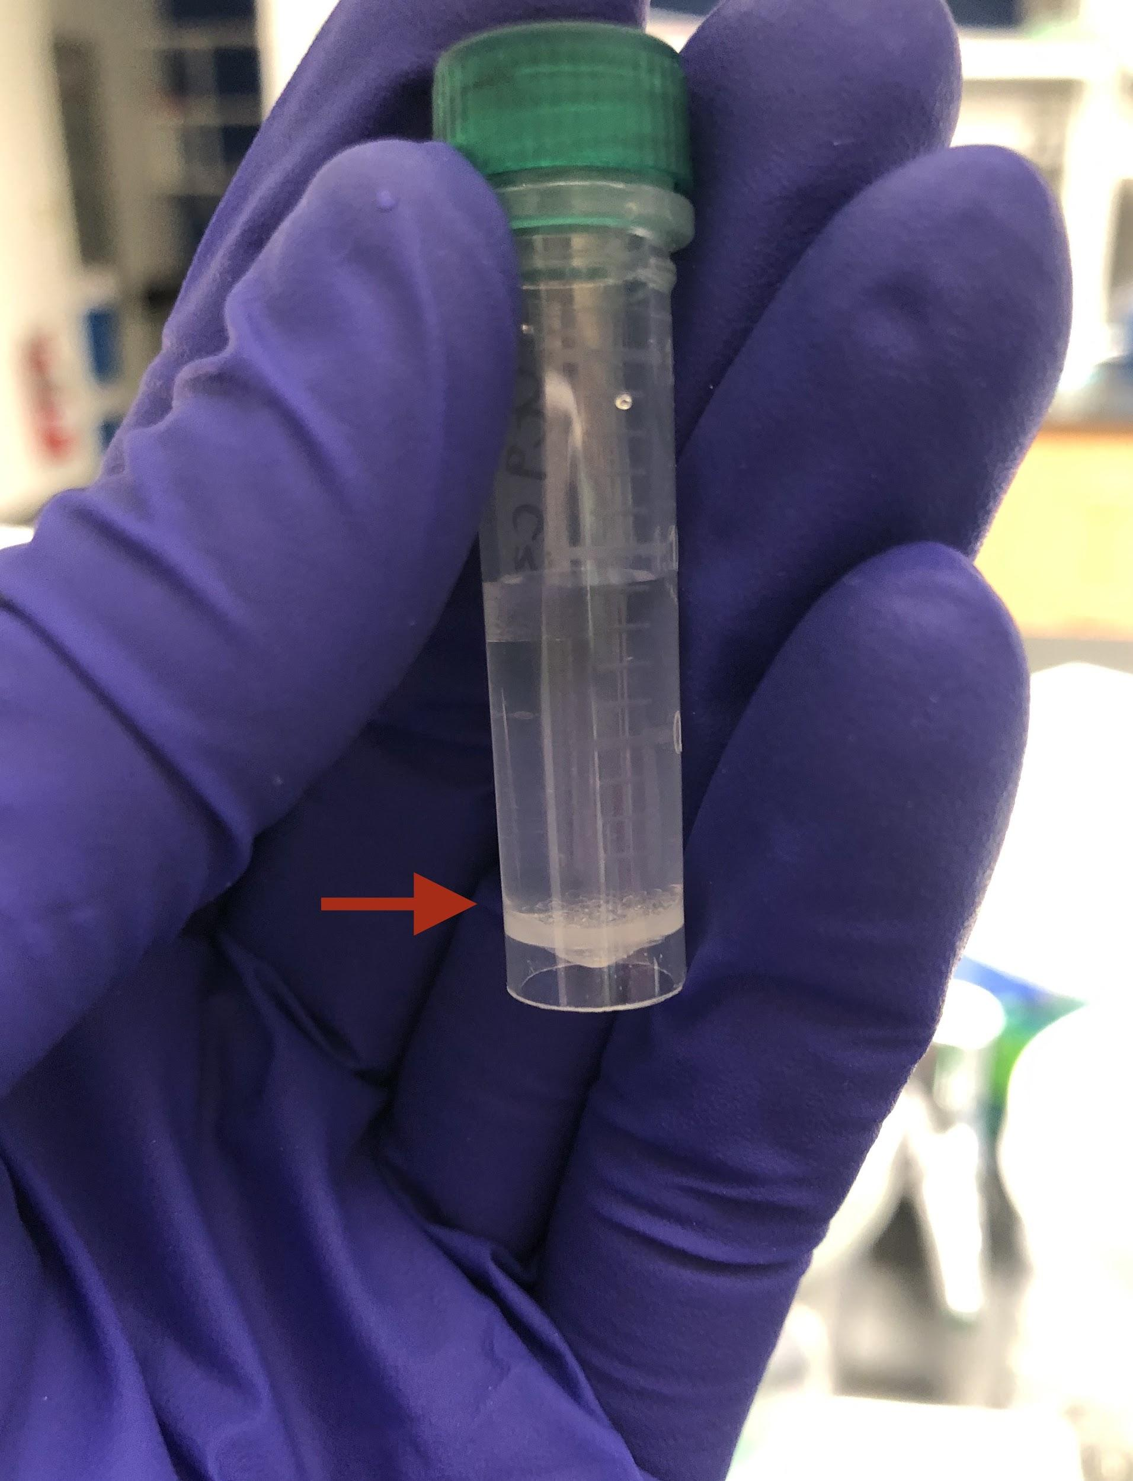
9. Run the samples in the bead mill at 6.00 m/s for 2 minutes.
10. Cover each sample with foil (should be in the incubation box) and incubate in darkness for 24 hours in the fridge.
11. After 24 hours, centrifuge the samples again for 3 minute at max RPM (14.8), 4℃.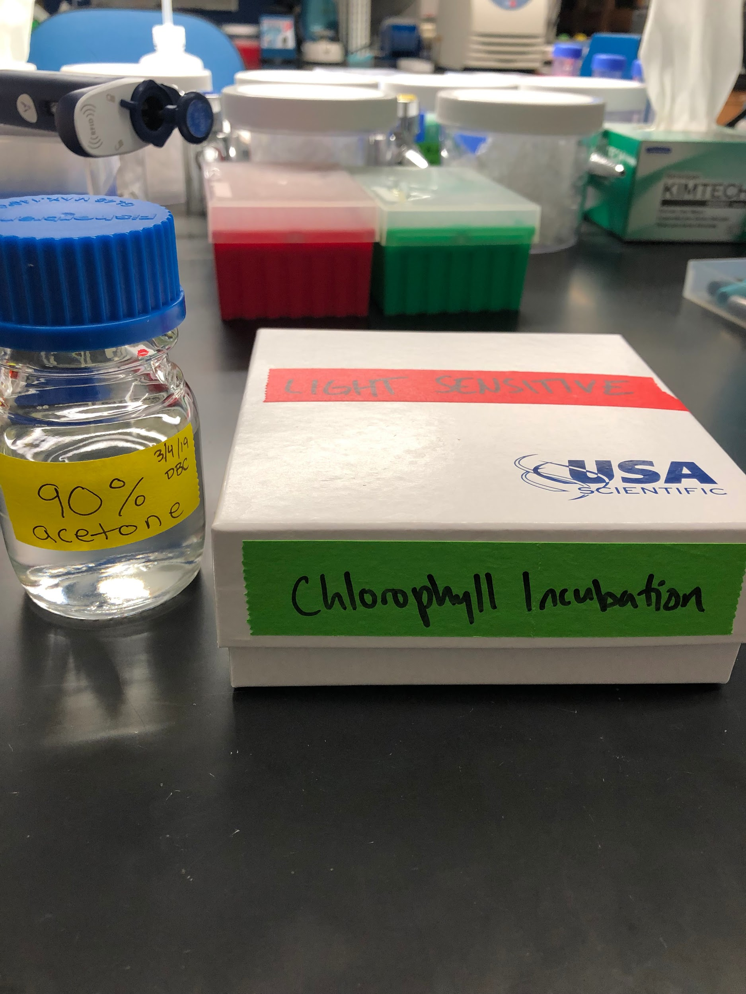
12. Plate samples in triplicate (200µg) and read absorbance at 630nm and 663 nm, use 90% acetone as blank. See picture for plate layout.
13. Clear lidded assay plates (REF#:3370, <https://ecatalog.corning.com/life-sciences/b2c/US/en/Permeable-Supports/Inserts/Corning%C2%AE-96-well-Clear-Polystyrene-Microplates/p/3370?clear=true>) or black assay plates with clear bottoms can be used, but plate type must be consistent within a project. Plates can be rinsed and reused between readings.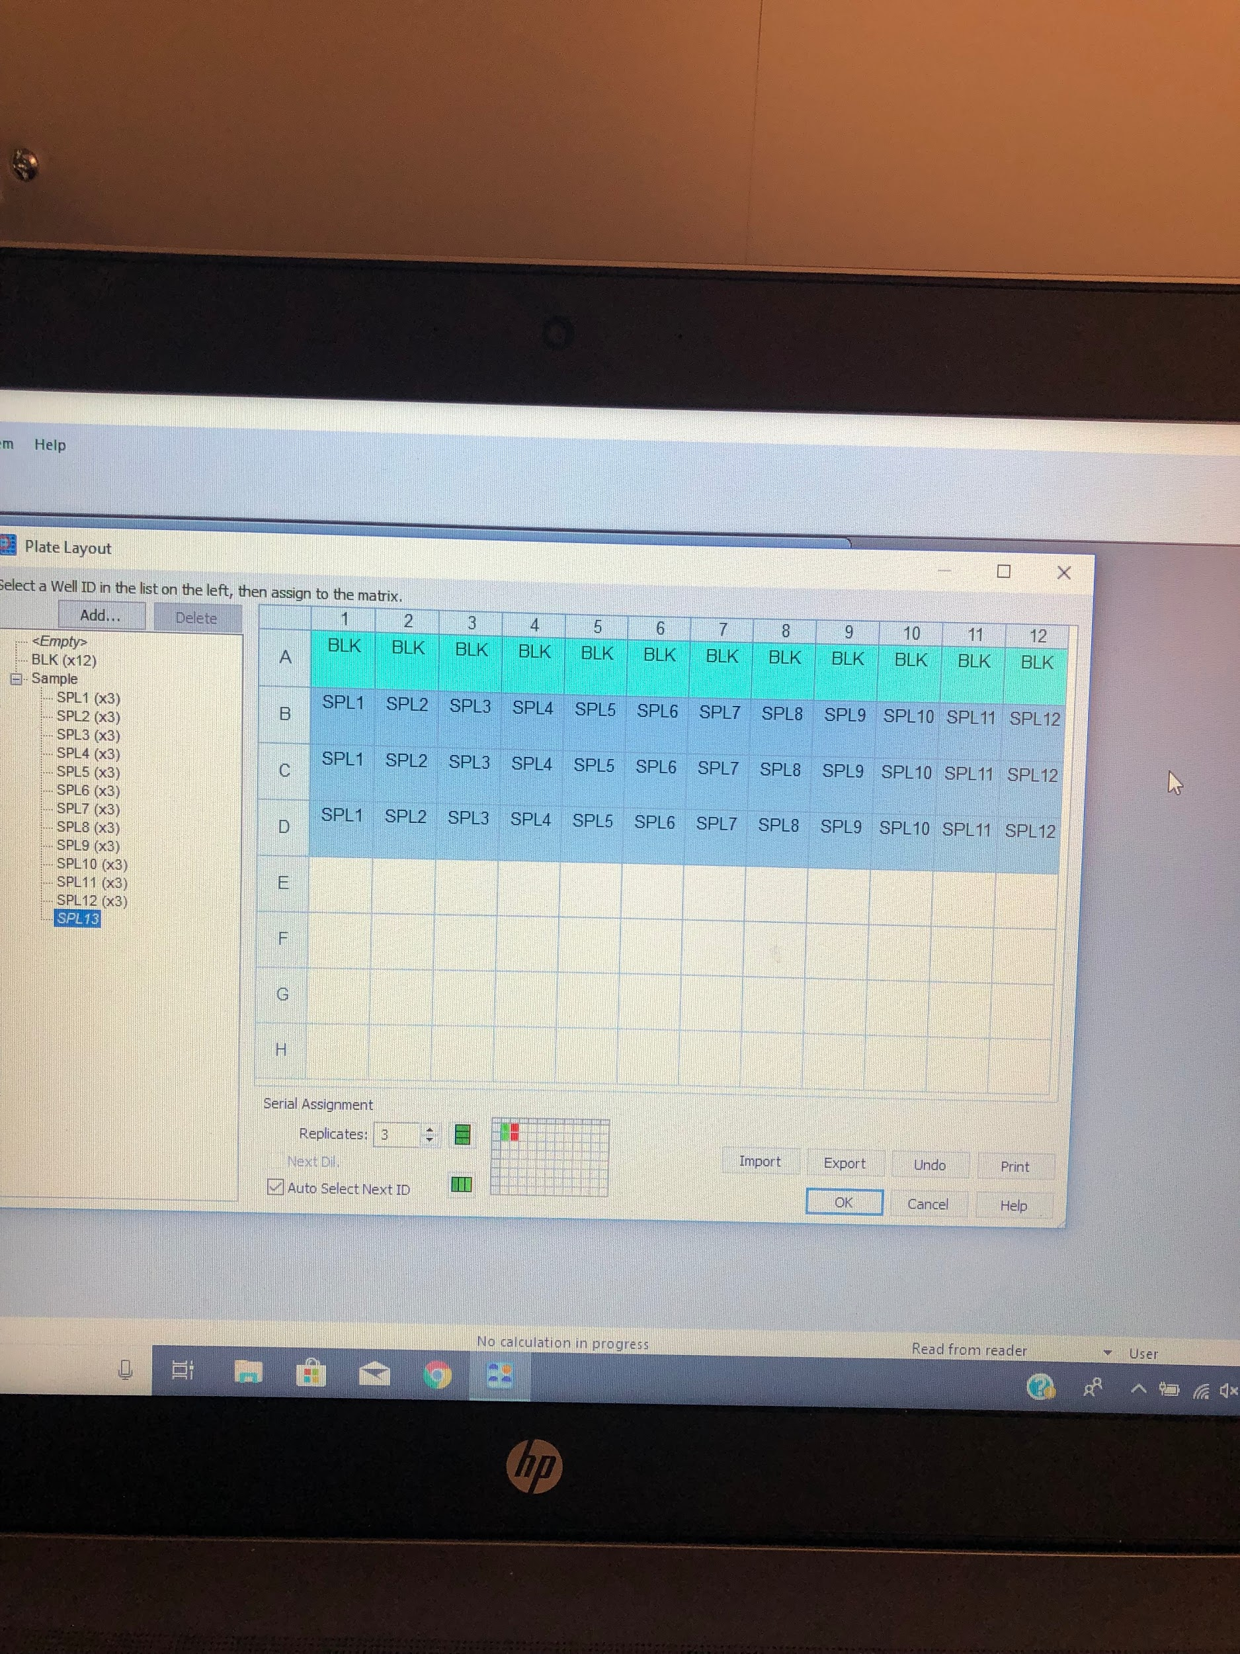
14. The formula for ChlA concentration=(13.31*Blk 663 average)-(0.27*Blk 630 average). The formula for ChlC2 concentration=(-8.37*Blk 663 average)+(51.72*Blk 630 average).